RESEARCH ARTICLE

Roadside Traffic Counting and Next-Segment Congestion Classification with Pretrained YOLOv8l and YOLO11l: Matched Pilot and Expanded Evaluations
Puligadda Charishma, Althi Bhargavi, Nossam Revanth Kumar Reddy, Alavalapati Naga Thanmai
Guide: Dr. T. Praveen
Department of Computer Science and Engineering, Koneru Lakshmaiah Educational Foundation (KLEF), Vaddeswaram, Guntur, Andhra Pradesh, India
A B S T R A C T
We document three sequential evaluations of roadside vehicle counting and next-segment congestion classification. COCO-pretrained YOLOv8l and YOLO11l with ByteTrack first process the same 80 source clips from four cameras. On a class-balanced 48/32 chronological train/test split, the original XGBoost pipelines both obtain 37.5% accuracy; YOLOv8l and YOLO11l report 2,142 and 2,162 predicted crossings, respectively. A cached-feature re-evaluation selects classifiers using three chronological training-date validation folds. Regularized XGBoost achieves 50.0% accuracy and 0.4941 macro-F1 for YOLO11 features, versus 40.625% and 0.4033 for YOLOv8. A subsequent YOLO11 experiment expands to 448 training and 64 different evaluation clips, reusing 48 completed training clips and processing 464 new clips. Context/motion features lead validation to select logistic regression, which achieves 71.875% accuracy, 46.731% balanced accuracy and 0.4283 macro-F1. Its accuracy is below the majority baseline (81.25%) and label-persistence baseline (79.688%), although its macro-F1 is higher. The expanded test contains 52 free-flowing, six heavy-delay, five light-delay and one moderate-delay clip. Thus the rise from 50% to 71.875% is not a controlled accuracy improvement: test composition and the selected classifier changed. All evaluation dates were previously examined; untouched dates and manual vehicle-level annotations remain necessary for generalization and detection/counting accuracy claims.

1. Introduction
Urban road networks in rapidly motorising regions face recurring congestion that raises travel time, fuel use, and emissions. Intelligent Transportation Systems (ITS) depend on continuous, low-cost measurement of traffic volume, and roadside CCTV is attractive because it is already deployed at scale and captures vehicle class, direction, and spatial density in one stream. Inductive loops and radar can measure traffic without providing the visual context of CCTV; loops require installation in the road surface.
Vision-based counting has advanced quickly with one-stage detectors, yet deployed systems still degrade in conditions that are common rather than exceptional: dusk and night scenes, rain streaks and wet-road reflections, headlight glare, and dense mixed traffic in which two-wheelers, auto-rickshaws, cars, buses, and trucks overlap. Three failure modes dominate. First, detector confidence collapses and objects flicker between frames. Second, the tracker reassigns identities after occlusion, so one vehicle yields several track IDs. Third, a rigid counter treats every tripwire crossing as one full vehicle, so these errors translate directly into overcounting.
Beyond counting, operators need an anticipatory signal. Raw counts alone say little about queue build-up, because the same flow can be free or congested depending on speed and spacing. Short-term forecasting of a coarse congestion state is therefore more actionable than a count history.
This study contributes the following:
- A matched comparison of pretrained YOLOv8l and YOLO11l on the same 80 clips, using a common ByteTrack counter and identical chronological classification split.
- Direction-aware hard counts and exploratory confidence-weighted soft counts by vehicle class, with an auditable detailed clip.
- Descriptive analyses of 95,235 processed frames, detector confidence, bounding-box area, per-camera predicted counts, and vehicle presence over time.
- A documented sequence of original XGBoost evaluation, cached-feature classifier selection, and expanded YOLO11 evaluation, with within-sample baselines and explicit comparison limits.
- Explicit limits on inference: balanced and naturally sampled holdouts have different class proportions; the absence of manual vehicle-level annotations prevents detection, tracking and counting accuracy estimates.

2. Related Work

2.1 Object detection for traffic scenes
One-stage detectors descend from the YOLO family introduced by Redmon et al. [1], which frames detection as single-pass regression, in contrast to two-stage detectors such as Faster R-CNN [12] and other one-stage designs such as SSD [13]. YOLOv3 [11] and YOLOv7 [14] extended this line with multi-scale prediction and trainable bag-of-freebies, and models are commonly pretrained on MS COCO [20]. Successive releases improved accuracy and speed through better backbones, feature pyramids, and training recipes. YOLO11 [2], released by Ultralytics, refines the C3k2 blocks and attention components [15] and offers a favourable accuracy-latency trade-off, which suits edge-deployed roadside analytics. Benchmarks such as UA-DETRAC [3] have driven research on vehicle detection, though they under-represent the heterogeneous traffic typical of South Asian roads. Recent studies evaluate YOLO11 with ByteTrack or BoT-SORT for traffic counting [10].

2.2 Multi-object tracking
SORT [4] couples a Kalman filter with Hungarian assignment on IoU, and DeepSORT [5] adds appearance embeddings to reduce identity switches. ByteTrack [6] associates nearly every detection box, including low-confidence ones, in a second matching pass, which recovers occluded objects and reduces fragmentation without an appearance model. BoT-SORT [16] adds camera-motion compensation, OC-SORT [17] reduces error accumulation during occlusion, and StrongSORT [18] upgrades DeepSORT with stronger appearance and motion models. ByteTrack’s reliance on detector scores motivates our use of track-level confidence as a counting weight.

2.3 Vehicle counting
Tripwire or virtual-line counting remains the standard practical method because of its simplicity. Region-based and density-regression counters avoid tracking but lose per-class and directional detail. Existing line-crossing counters generally apply a hard integer increment, so counting accuracy is bounded by tracker identity stability. Recent work on YOLO-SORT counters documents sensitivity to fog, rain, and camera viewpoint [9], YOLOv8 with ByteTrack has been applied to line-crossing entry and exit counting on surveillance footage [25], and aerial pipelines pair YOLO11 with ByteTrack [24].

2.4 Low-light and adverse-weather enhancement
Contrast Limited Adaptive Histogram Equalisation (CLAHE) [7] builds on adaptive histogram equalisation [19] and equalises local histograms with a clip limit that bounds noise amplification. Applying it on the luminance channel rather than on RGB channels prevents colour distortion. Learning-based enhancement and de-raining networks give stronger results but add latency and training cost.

2.5 Traffic state forecasting
Classical approaches use seasonal ARIMA [22] and Kalman filtering on loop-detector series, while recent work applies deep architectures [21], LSTM networks [23], graph neural networks, and gradient-boosted trees. Gradient boosting [8], including LightGBM [26], performs well on small tabular datasets and offers interpretable feature importance, which fits window-level features derived from video.

2.6 Research gap
Prior work often studies detection, counting, and forecasting separately. This paper reports an integrated, measured pilot pipeline and distinguishes its descriptive counts and uncalibrated soft count from validated counting accuracy.

3. Methodology

3.1 System overview
Each detector pipeline chooses resolution-aware inference settings, detects COCO vehicle classes, associates tracks with ByteTrack, and records virtual-line crossings. Each new clip resets the tracker. The same tripwire, feature definitions, sampled clips, labels and train/test split are used for YOLOv8l and YOLO11l. A separate XGBoost classifier is fitted to each feature set to predict the next contiguous labeled segment. This is Stage A. Stage B reuses its features for validation-based classifier selection; Stage C expands the YOLO11 source sample and adds context/motion features (Section 3.11).

3.2 Dataset and experimental setup
The label file contains 16,076 rows. Stage A, the original matched experiment, uses 80 source clips, 20 per Norman Niles camera, with 12 training and eight held-out clips per future class. Training dates are 20-24 October 2025 and holdout dates are 25-26 October. The next segment starts 58-69 seconds after the source start. Each detector processed the same 95,235 frames (4,761.75 seconds), all at 960 x 540 pixels and 20 fps. COCO-pretrained yolov8l.pt and yolo11l.pt weights are used without fine-tuning. The YOLOv8 notebook embeds the completed YOLO11 selection; exported paths, target labels, split, frame counts and tripwire positions were matched before comparison. Vehicle boxes, manual counts, track identities and weather labels are unavailable as ground truth. Stage B reuses exactly these 80 clips and the same 32 evaluation clips. Stage C uses 448 training and 64 different later-date evaluation clips, still from the same recording week; Table 8 summarizes the protocols.

3.3 Adaptive visual preprocessing
An illumination-triggered CLAHE variant remains a proposed enhancement. It was not activated in this run. The implemented preprocessing applies unsharp masking only for the low-resolution tier, while the 960 x 540 study clips use the HD tier without sharpening.
$$\hat{V}\left(x,y\right)=\text{CLAHE}\left(V\left(x,y\right); \text{clipLimit}=2.0, \text{tileGrid}=\left(8,8\right)\right)$$
$$\tilde{I}\left(x,y\right)=\text{HSV_to_BGR}\left(H\left(x,y\right), S\left(x,y\right), \hat{V}\left(x,y\right)\right)$$
CLAHE on the HSV value channel with a clip limit of 2.0 and an 8 x 8 tile grid is a future experiment, not a component of the reported 80-clip execution. Weather- or illumination-conditioned benefits have not been evaluated.

3.4 Detection with YOLOv8l and YOLO11l
Both pretrained detectors return bounding boxes, confidence scores and COCO classes. Both runs use an inference size of 1,280 pixels and confidence threshold of 0.05 on these HD clips, the same vehicle classes and ByteTrack settings, and a horizontal tripwire from (48, 270) to (912, 270). The large variants have different parameter counts. Older 50-clip exploratory exports used different settings and are excluded from this matched comparison. Stage C retains pretrained YOLO11l and the same HD inference settings; it does not fine-tune the detector.

3.5 Tracking with ByteTrack
ByteTrack associates detections and assigns track IDs. Its state is reset at the start of each new clip; persist=True is used only across frames within a clip. The v2 run records frame/track observations, directional crossing events, the counting line, model/tracker settings, and each crossed track's confidence history. These are model-generated logs, not manually labeled track identities.

3.6 Directional hard counting and exploratory confidence weighting

3.6.1 Implemented confidence-weighted soft count
The hard counter increments once for each track ID crossing the virtual line in a clip. The exploratory soft count sums the mean YOLO confidence over observations of each crossed track:
Csoftc=i∈Tc​wi, wi=1Fif∈Fi​sfi
Here the track set includes only tracks that crossed the line, the frame set contains detections associated with a given track, and each confidence lies between zero and one. This confidence-weighted sum is not calibrated as a vehicle count; without manual counts it cannot be judged more accurate than the integer hard count.

3.6.2 Directional flow gating
Let L be the directed tripwire vector and D the displacement between the last off-line and current tracked centroids. Direction uses the sign of their two-dimensional cross product in image coordinates:
Exiting if (L x D) > 0; entering if (L x D) < 0. A crossing is counted only when the centroid segment intersects the configured finite tripwire.
The default tripwire runs horizontally from 5% to 95% of the image width at mid-height; it can be calibrated separately per camera. When a center lands exactly on the line, the last off-line position is retained until the vehicle reaches a side. One crossing per track ID is counted in each clip.

3.7 Feature extraction and next-segment classification

3.7.1 Multi-feature congestion index (proposed)
$$CI_{t}=α⋅\frac{N_{\text{active}}\left(t\right)}{N_{\text{capacity}}}+β⋅\frac{{\overset{‾}{A}}_{\text{bbox}}\left(t\right)}{A_{\text{norm}}}+γ⋅\left(1-{\overset{‾}{s}}_{t}\right)$$
The proposed index combines active vehicle load, mean box area, and tracking confidence. Scene-capacity and area-normalisation constants and feature weights require a validation set. No index score was computed or evaluated for the available results.

3.7.2 Video-window features and XGBoost next-segment classifier
Each source clip supplies the following measured feature vector:
Hard total, entering and exiting counts; per-class car, motorcycle, bus and truck counts; mean and maximum tracked vehicles per frame; flow rate; mean and standard deviation of box area; mean detection confidence; and the uncalibrated soft count.
In Stage A, an XGBoost classifier [8] was fitted to predict the next contiguous segment's entering-congestion rating (free flowing, light, moderate, or heavy delay). Pairing used the same camera and a 0-2 second gap between segment end and next start. Source clips were selected across future classes and camera views. The 48 training clips came from 20-24 October 2025; 32 held-out clips came from 25-26 October. The feature extractor never used target-window video frames, and the test dates were not used for fitting. Accuracy, macro-F1, a notebook-defined 0.7 macro-F1 + 0.3 accuracy composite, and persistence were evaluated on the held-out set.
Algorithm 1: Original matched-pilot processing and evaluation (Stage A)
Input: CCTV clips, camera tripwire, COCO-pretrained YOLOv8l or YOLO11l, labeled segment table
Output: Hard and soft predicted counts, features, next-segment holdout predictions
1. Select contiguous source/target label pairs; sample across cameras and future classes.
2. For each source clip, reset ByteTrack and choose resolution-aware settings.
3. Detect and associate vehicles on successive frames; record boxes, confidence, track ID and centroid.
4. Count a track once if its centroid trajectory crosses the finite tripwire; log event, class and direction.
5. Sum mean track confidences over crossings for the exploratory soft count.
6. Export per-clip features; train XGBoost on earlier dates and evaluate on later dates.
7. Compare next-segment predictions with persistence on the same 32 test clips.
Note: CLAHE and a calibrated congestion index were not evaluated.
8. Repeat with the other detector on the same clips; compare predictions and descriptive counts.

3.7.3 Adaptive resolution tiers
Table 1 lists the implemented resolution-tier settings. All 80 selected clips use the HD tier (960 x 540 pixels).

Table 1. Resolution-aware inference settings implemented in the executed notebook.
Resolution tier | Frame-size rule | imgsz | conf_thresh | Unsharp mask
Low | width x height < 854 x 480 | 1280 | 0.05 | ON
HD | 854 x 480 to 1920 x 1080 pixels | 1280 | 0.05 | OFF
High | width x height > 1920 x 1080 | 1920 | 0.05 | OFF

3.8 Evaluation metrics
The export supports descriptive detection and predicted-count statistics, as well as next-segment classification accuracy, macro-F1, balanced accuracy in the expanded run, and a confusion matrix against the provided congestion labels. Detection mAP still needs manually annotated boxes; MOTA needs per-frame identity labels; count MAE/RMSE needs manual tripwire counts. Those annotations are absent, so these three families of metrics and weather robustness are not reported. Source-video FPS is not inference throughput. Balanced accuracy is the mean recall over the four represented classes; macro-F1 is their unweighted mean F1. Both are reported beside ordinary accuracy because natural class prevalence can make a constant predictor appear accurate.

3.9 Analytical properties of confidence-weighted soft counting
This subsection derives what soft counting does and does not guarantee. The analysis is independent of any dataset, so it holds for every scene.
Setting. Let a physical vehicle $v$ generate $k_{v}≥1$ tracks that cross the tripwire, because of identity switches or fragmented boxes. Let the weights of these tracks be $w_{v,1},…,w_{v,k_{v}}$, each in $(0,1]$. Hard counting contributes $k_{v}$ for this vehicle and soft counting contributes j​wv,j.
Property 1 (soft never exceeds hard). Since every weight is at most 1,
Csoft=v​j=1kvwv,j ≤ v​kv=Chard
with equality only if every crossing track has weight exactly 1. Soft counting therefore can only reduce a count, never raise it, so it is a corrective for overcounting and cannot fix undercounting caused by missed vehicles.
Property 2 (error decomposition). Let $N$ be the true number of vehicles crossing, $M$ the number of vehicles that were missed entirely, and F=v​kv-1 the number of surplus fragments. Then the signed error of the two estimators is
Ehard=F-M, Esoft=v​j=1kvwv,j-1
Soft counting reduces the error whenever the discount applied to surplus fragments is larger than the discount wrongly applied to well-tracked vehicles. Writing ${\overset{‾}{δ}}_{1}=E\left[1-w\right]$ for the mean discount on single-track vehicles and ${\overset{‾}{w}}_{f}$ for the mean weight of a surplus fragment, soft counting is preferable to hard counting in absolute terms when approximately
$$|F\left(1-{\overset{‾}{w}}_{f}\right)⋅\left(-1\right)+\left(N-M\right) {\overset{‾}{δ}}_{1}| < |F-M|$$
that is, when low-confidence fragments are discounted substantially while confidently tracked vehicles are discounted little. This condition depends on the confidence distribution, which is why the confidence profile in Figure 2 is a diagnostic of how much soft counting can help.
Property 3 (bias and calibration). Confidence weights below one make the soft count no larger than the hard count. The detailed clip's observed values are 2.8346 soft versus four hard crossings; across the 80 clips they are 1,572.36 versus 2,162. Neither difference is an error reduction without a manual count. A calibration factor, if desired, must be learned on separate annotated validation clips.
Property 4 (class-wise and directional additivity). Because the sum runs over tracks, soft counts are additive over classes and directions, Csoft=c​Csoftc=Csoftenter+Csoftexit. Net flow $C_{\text{soft}}^{\text{enter}}-C_{\text{soft}}^{\text{exit}}$ and the entering ratio are therefore well defined without extra assumptions.
Computational complexity. Preprocessing is linear in the number of pixels per frame; network detection dominates total work, while track association and line checks depend on active tracks. The implementation saves per-frame observations and per-track confidence histories for audit, so memory and log volume grow with processed detections. No inference-throughput benchmark was recorded.

3.10 Implementation details
The Colab notebooks use Ultralytics, ByteTrack, OpenCV and XGBoost, storing one row per completed clip and separate model-specific outputs. Resume skips completed rows and restarts an interrupted clip at frame zero. The two original Stage-A classifiers use 200 estimators, depth 5, learning rate 0.08, subsample and column sample 0.9, histogram trees and random seed 42. The final YOLOv8 session reports a Tesla T4, Ultralytics 8.4.183 and XGBoost 3.4.1; its folder contains a run summary but no per-clip manifests. Package versions and hardware across historical checkpoints cannot be independently matched. CLAHE and the proposed congestion index remain untested.
3.11 Sequential forecasting experiments and reproducibility
Stage A (original matched pilot) supplies the 14 measured features and the archived 48/32 balanced split described above. Stage B (cached-feature re-evaluation) processes no new video: it reuses each detector's completed feature table and the same 32 test clips. Six fixed candidates are compared on validation dates 22, 23 and 24 October 2025. Each fold fits only source clips whose source and target times precede that day. Numeric median imputation, scaling and camera one-hot encoding are fitted within each training fold. The winner is selected by mean validation macro-F1, then accuracy and candidate name; the selected model/settings are saved before test predictions are produced.
The candidates are original XGBoost with 14 base features; regularized XGBoost with base or context features; and shallow XGBoost, random forest and logistic regression with context features. Context adds directional/class shares, normalized box statistics, density/count ratios, cyclic source time and camera identity (28 inputs without motion). Regularized XGBoost uses 150 trees, depth 2, learning rate 0.04, minimum child weight 3, L2 penalty 10, L1 penalty 0.5, and row/column sampling 0.85. Shallow XGBoost uses 100 trees, depth 1, learning rate 0.05, minimum child weight 2 and L2 penalty 10. Random forest uses 250 trees, depth 5, minimum leaf size 3 and feature fraction 0.7; logistic regression uses C=0.3 and at most 1,500 iterations. All use seed 42. Class-balanced training weights are applied except to the original-settings XGBoost control.
Stage C (expanded YOLO11) begins with a filename/label audit. The Drive inventory has 18,532 accessible videos: 15,892 match the 16,076 labelled paths, 184 labelled paths are missing, and 2,640 videos lack matching labels. Twenty records with nonpositive segment duration are excluded from source/target pairing. Source/target segments share a camera and a 0–2 second end/start gap. Sampling uses camera/date and seed 42, without target-class balancing for the additional clips: up to 20 new training clips per camera/day on 20–24 October plus the 48 completed training clips, and eight new evaluation clips per camera/day on 25–26 October. The resulting split is 448/64. The historical source/target clips and two-minute neighborhoods are excluded from the new test; the frozen selection and labels are verified when resuming. Target video frames never enter the source feature extractor.
Stage C reuses 48 completed training feature rows and processes 464 new source clips with YOLO11l and ByteTrack, checkpointing only completed clips. Its 512 source records contain 613,237 frames (30,661.85 seconds), with source/target start horizons of 52–63 seconds. Complete observation-log coverage enables six further inputs: median and 90th-percentile normalized image motion, slow-observation fraction, bounding-box occupancy proxy, density trend and density variability (34 total context/motion inputs). Empty frames contribute to density summaries; image motion is not calibrated road speed and overlapping box areas are not true road occupancy. The same chronological validation procedure selects the classifier, which is then evaluated once on the frozen 64 clips for this run. Figure 5 illustrates the sequence.
The Stage-B exports and Stage-C run report scikit-learn 1.6.1, XGBoost 3.4.1, pandas 2.2.3 and NumPy 2.1.3. Stage-C clip manifests record Ultralytics 8.4.184. Its archive retains features, validation folds, selected settings, predictions for every baseline, class supports, a confusion matrix and checkpoint metadata. Input/plan hashes and the 464 new clips' manifests and crossing logs were checked against the export. Historical Stage-A software/hardware equality is not established; refitting its settings under the later environment is a new control, not an exact replay. All dates had already been examined, so Stages B and C remain exploratory even though model selection uses training dates only.

4. Results and Evaluation
The results are reported in execution order. Tables 1–7 and Figures 1–4 retain Stage A, the original matched 80-clip analysis; Table 8 and Figure 5 describe the full experimental sequence. Table 9 reports the cached Stage-B comparison, while Tables 10–11 report Stage C. These tables preserve each experiment's own test set and baselines.

4.1 Detection confidence analysis
The detailed 59.9-second camera-1 clip yielded 686 tracked detections: mean confidence 0.5677, median 0.6219, standard deviation 0.2375, and range 0.0520-0.9124. The confidence bands (Figure 2) contain 120 low (17.5%), 206 medium (30.0%), 232 high (33.8%), and 128 very high (18.7%) detections. Threshold summaries report 439 above 0.5 (64.0%), 277 above 0.7 (40.4%), and four above 0.9 (0.6%). These are detector scores, not precision or recall against annotated boxes.

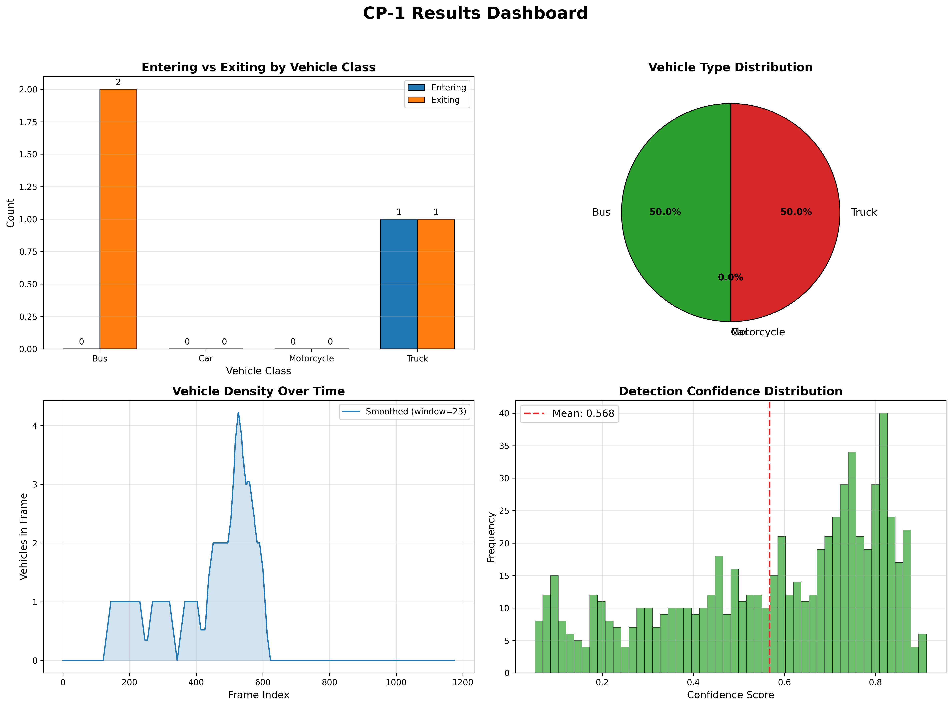
Figure 1. Executed-v2 dashboard for the detailed clip: predicted entering/exiting class counts, vehicle-type distribution, smoothed tracked vehicles per frame, and detection-confidence distribution (mean 0.568).

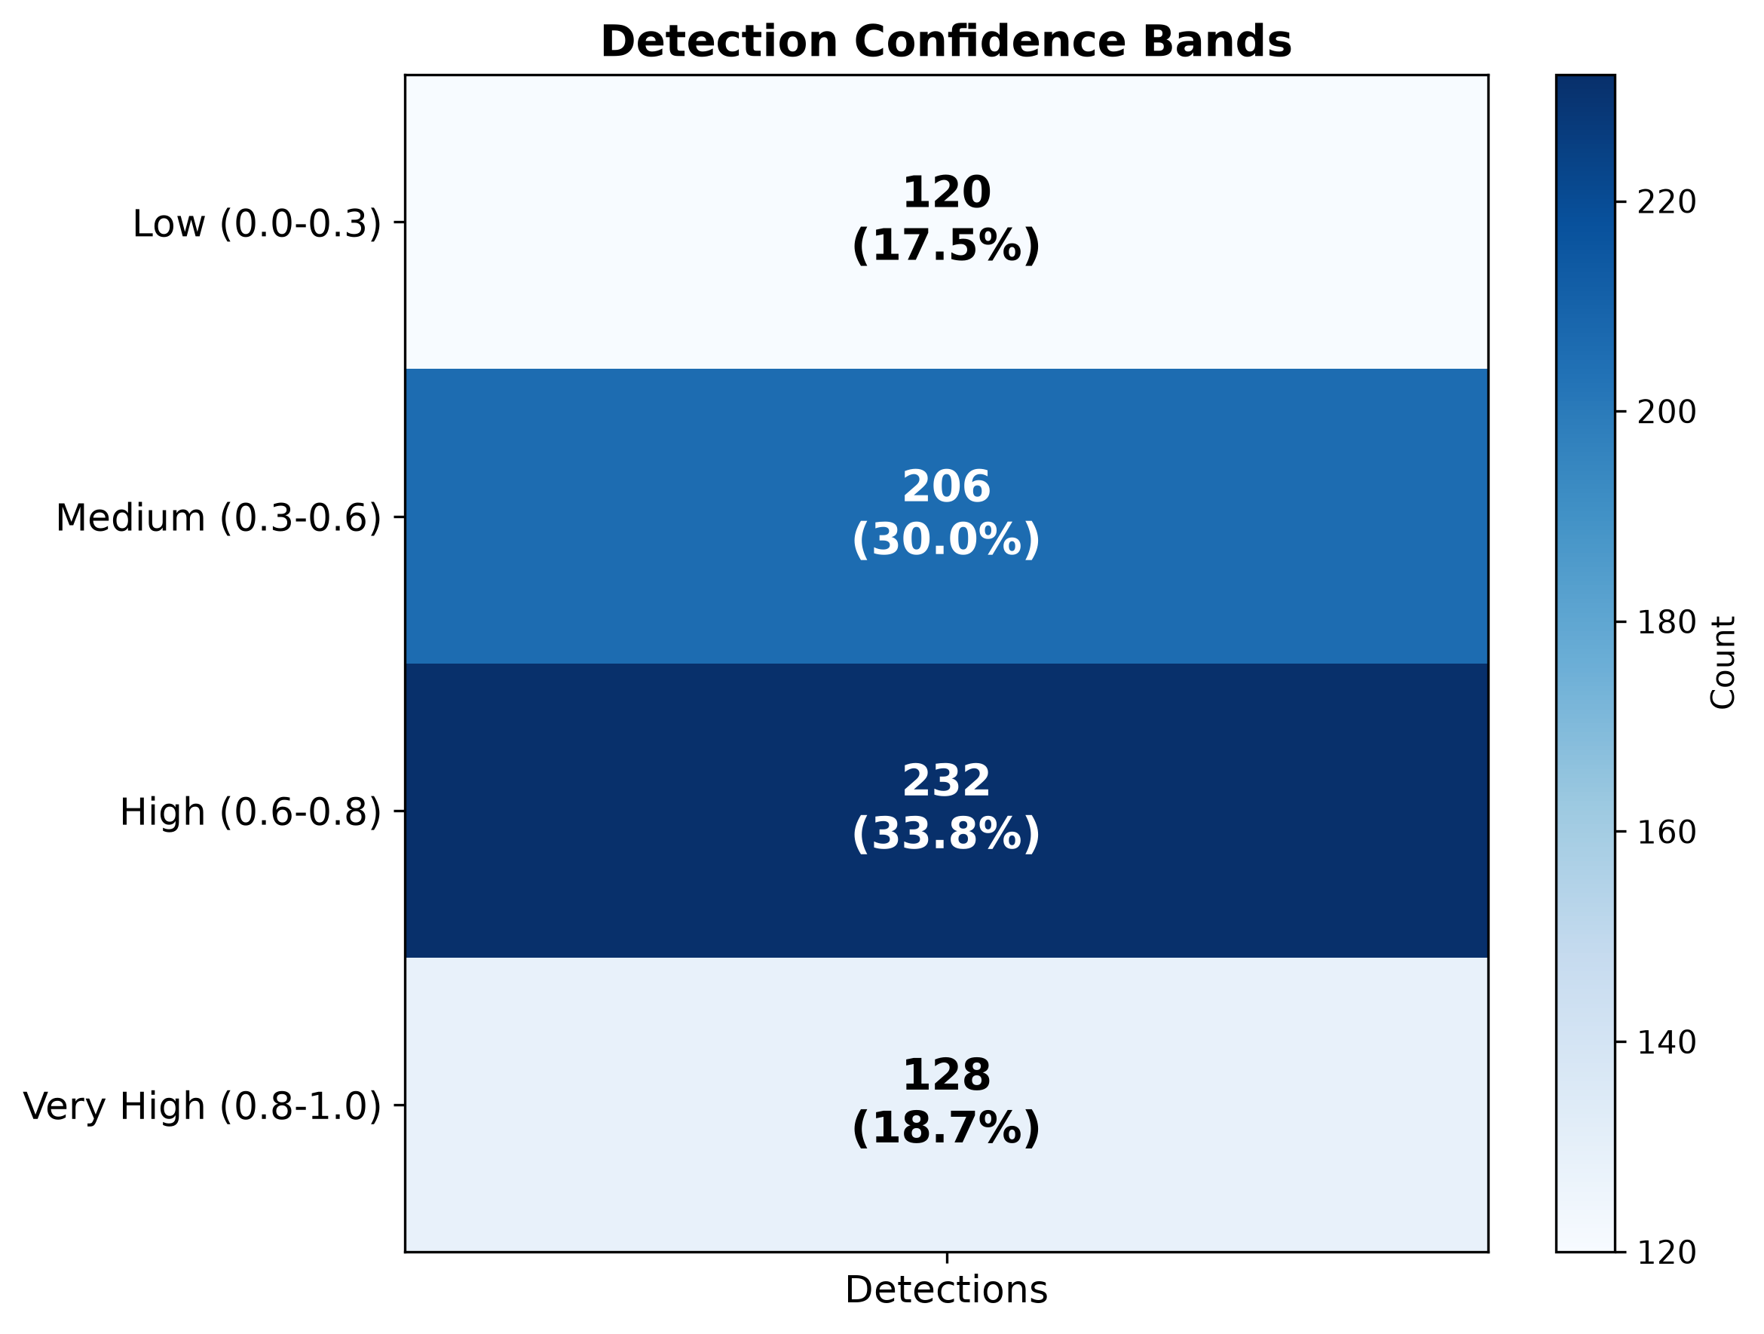
Figure 2. Detection-confidence bands from 686 tracked detections: 120 low, 206 medium, 232 high, and 128 very high. This is not a ground-truth confusion matrix.

4.2 Directional flow and class composition
Table 2. Predicted directional tripwire crossings in the detailed executed-v2 clip.
Class | Entering | Exiting | Total | Share (%)
Bus | 0 | 2 | 2 | 50.0
Car | 0 | 0 | 0 | 0.0
Motorcycle | 0 | 0 | 0 | 0.0
Truck | 1 | 1 | 2 | 50.0
Total | 1 | 3 | 4 | 100.0
The detailed clip has four predicted crossings: one entering and three exiting (25% entering). Two buses exit; one truck enters and one exits; no car or motorcycle crosses the line (Table 2 and Figure 3). The uncalibrated soft count is 2.8346, obtained by summing mean confidence of the four crossed tracks. Without manual crossing labels, neither the hard nor soft count has a measured error.

4.3 Detection size distribution
The detailed-clip mean predicted box area is 5,970.1 square pixels. Figure 3 displays its distribution and directional flow; the plot alone does not provide ground-truth box-size or localization accuracy.

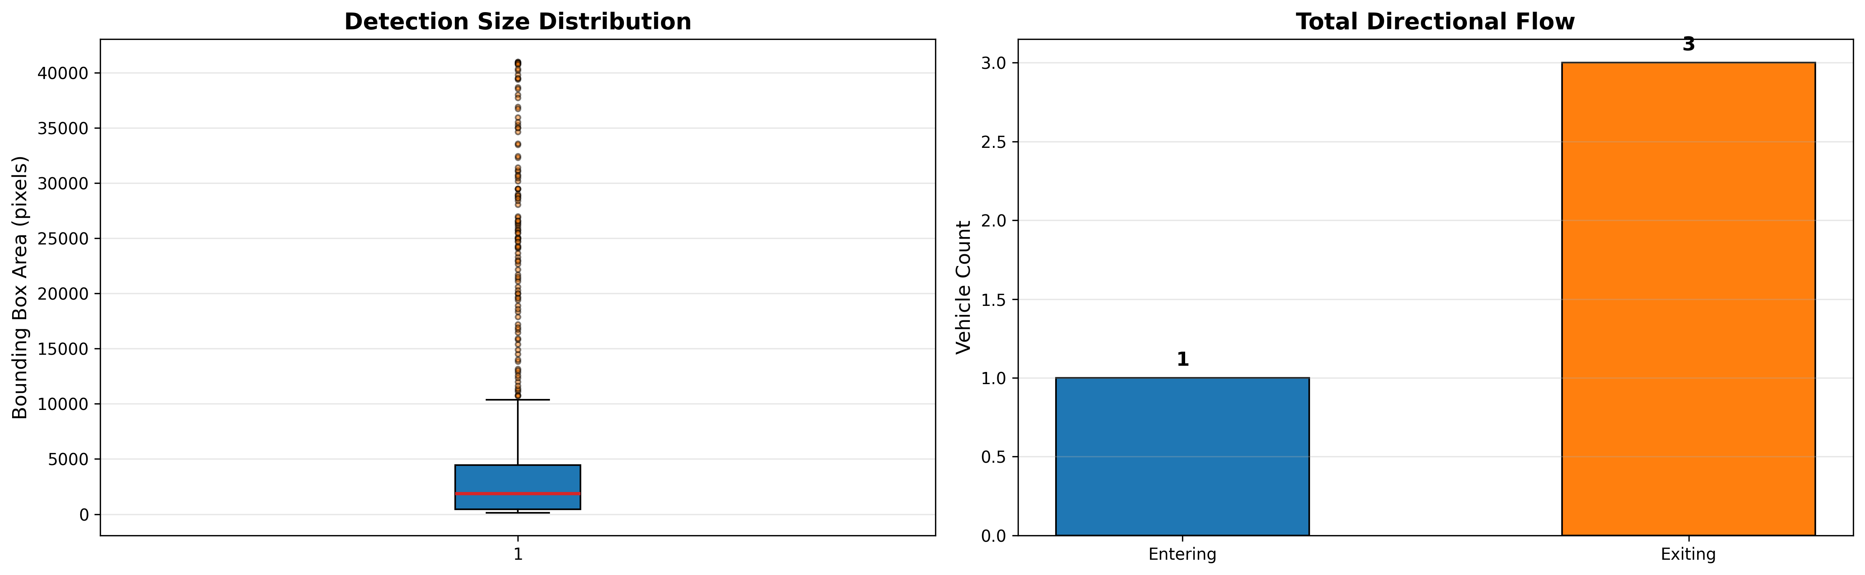
Figure 3. Predicted box-area distribution (left) and directional flow (right: one entering, three exiting) in the detailed clip.

4.4 Traffic density over time
The detailed clip contains a mean of 0.5726 tracked vehicles per frame. Figure 1 plots a smoothed presence curve; this describes visible tracked objects, not a labeled congestion episode. The next-segment classifier was evaluated separately on the 80 selected source clips.

4.5 Eighty-clip counts and next-segment classification

Table 3. Predicted tripwire crossings in the selected 80 clips by camera. Soft counts are uncalibrated confidence-weighted sums.
Camera | Clips | Entering | Exiting | Hard total | Soft sum
Camera 1 | 20 | 343 | 348 | 691 | 495.18
Camera 2 | 20 | 244 | 178 | 422 | 322.19
Camera 3 | 20 | 168 | 409 | 577 | 424.27
Camera 4 | 20 | 242 | 230 | 472 | 330.72
Total | 80 | 997 | 1165 | 2162 | 1572.36

Across 80 selected clips, YOLO11l and ByteTrack processed 95,235 frames (4,761.75 seconds) and reported 2,162 hard crossings: 997 entering and 1,165 exiting. The soft-count sum was 1,572.36; it cannot be interpreted as more accurate without manual counts. Class totals were 1,703 cars, 421 trucks, 28 buses, and 10 motorcycles. Camera-1/2/3/4 hard totals were 691/422/577/472 respectively (Table 3). Source-clip hard-count means by future class were 15.45 for free flowing, 30.00 for light delay, 29.95 for moderate delay, and 32.70 for heavy delay; these are descriptive associations in a future-label-balanced sample, not causal or calibrated congestion thresholds.
In Stage A, the 32 held-out clips contain eight examples per future class. Both YOLOv8l-feature and YOLO11l-feature XGBoost classifiers correctly predict 12/32 (37.5%). Their macro-F1 values are 0.3542 and 0.3784, with composite scores 0.3604 and 0.3774, respectively. Persistence correctly predicts 11/32 (34.4%; macro-F1 0.3354); the training-majority baseline achieves 25.0% accuracy. YOLO11 has a descriptively higher macro-F1 by 0.0242 but equal accuracy. No reliable model superiority is established by this small holdout. Table 4 gives aggregate scores, Tables 5-6 retain YOLO11 class details, and Figure 4 compares both confusion matrices.

Table 4. Next-segment held-out classification on the same 32 clips.
Method | Correct / 32 | Accuracy | Macro-F1 | 0.7 F1 + 0.3 Acc
YOLOv8l features + XGBoost | 12 | 0.3750 | 0.3542 | 0.3604
YOLO11l features + XGBoost | 12 | 0.3750 | 0.3784 | 0.3774
Persistence | 11 | 0.3438 | 0.3354 | 0.3379
Training-majority | 8 | 0.2500 | 0.1000 | 0.1450

Table 5. Per-class YOLO11-feature XGBoost precision, recall and F1 on the 32-clip holdout.
Future class | Precision | Recall | F1 | Support
Free Flowing | 0.556 | 0.625 | 0.588 | 8
Heavy Delay | 0.667 | 0.500 | 0.571 | 8
Light Delay | 0.200 | 0.125 | 0.154 | 8
Moderate Delay | 0.167 | 0.250 | 0.200 | 8

Table 6. YOLO11-feature XGBoost confusion matrix; rows are true future labels, columns are predictions.
True / predicted | Free Flowing | Heavy Delay | Light Delay | Moderate Delay
Free Flowing | 5 | 0 | 1 | 2
Heavy Delay | 1 | 4 | 0 | 3
Light Delay | 2 | 0 | 1 | 5
Moderate Delay | 1 | 2 | 3 | 2

4.5.1 Matched YOLOv8l and YOLO11l comparison
YOLOv8l reported 996 entering and 1,146 exiting crossings (2,142 total), versus 997 and 1,165 for YOLO11l (2,162 total). The 20-crossing difference is 0.93% of the YOLO11 total and is not a counting-error measurement. YOLOv8l class totals are 1,701 cars, 398 trucks, 31 buses and 12 motorcycles. Its camera-1/2/3/4 hard totals are 687/417/572/466, compared with 691/422/577/472 for YOLO11l. Table 7 summarizes the matched predicted outputs. Higher soft sums or confidence do not establish better counting accuracy.
Table 7. Descriptive predicted crossings on the same 80 clips. Soft sums are uncalibrated confidence weights.
Metric | YOLOv8l | YOLO11l
Hard total | 2142 | 2162
Entering | 996 | 997
Exiting | 1146 | 1165
Soft sum | 1600.43 | 1572.36
Car | 1701 | 1703
Truck | 398 | 421
Bus | 31 | 28
Motorcycle | 12 | 10
In the same detailed 59.9-second clip, YOLOv8l produced 577 tracked detections (mean confidence 0.6888), two hard crossings and soft sum 1.3986. YOLO11l produced 686 tracked detections (mean 0.5677), four hard crossings and soft sum 2.8346. These are separate single-clip diagnostics, not batch detection totals or validated count errors.

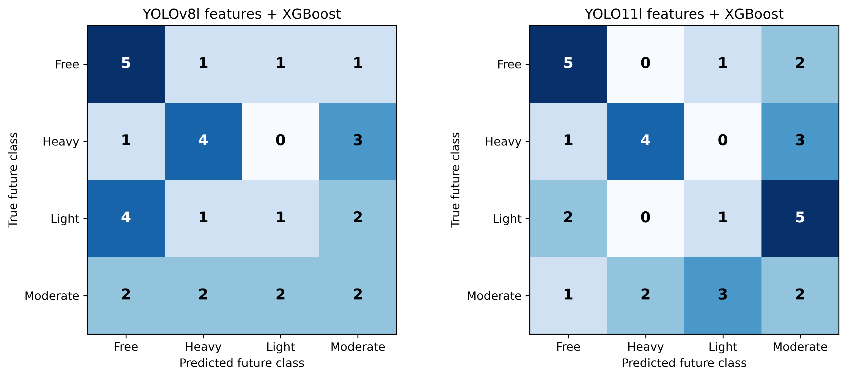
Figure 4. Stage-A original matched next-segment classification confusion matrices on the same 32 clips. Rows are true future classes, columns predicted classes; both matrices have 12 correct predictions. These evaluate congestion classification, not vehicle detection.

4.6 Cached-feature classifier re-evaluation and experimental sequence
Table 8 records how the reported scores were obtained. Stages A and B share the original 32 class-balanced test clips; Stage C uses a different 64-clip sample. Each percentage is an outcome for the indicated detector-feature and forecasting-classifier pipeline, not a vehicle-detection accuracy score.

Table 8. Sequential experiment protocols and selected-model outcomes. Stage-C test counts are free flowing / heavy delay / light delay / moderate delay; cross-stage accuracy differences are not controlled gains.
Stage | Detector | Train / test | Forecast classifier (inputs) | Test composition | Accuracy (%) | Macro-F1
A: original | YOLOv8l | 48 / 32 | Original XGBoost (14 base) | 8 per class | 37.500 | 0.3542
A: original | YOLO11l | 48 / 32 | Original XGBoost (14 base) | 8 per class | 37.500 | 0.3784
B: cached | YOLOv8l | 48 / 32 | Regularized XGBoost (28 context) | Same 8 per class | 40.625 | 0.4033
B: cached | YOLO11l | 48 / 32 | Regularized XGBoost (14 base) | Same 8 per class | 50.000 | 0.4941
C: expanded | YOLO11l | 448 / 64 | Logistic regression (34 context/motion) | 52 / 6 / 5 / 1 | 71.875 | 0.4283

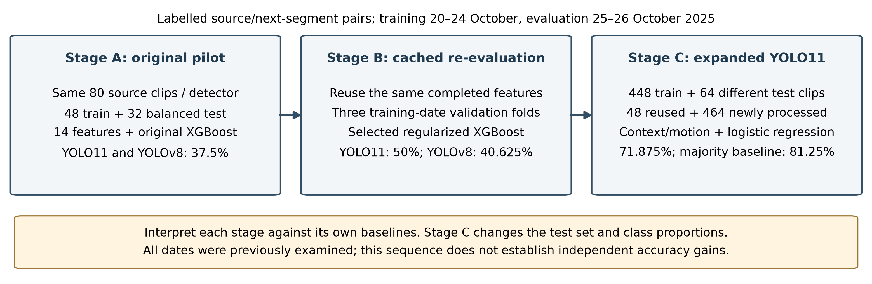
Figure 5. Process followed from the original matched pilot to cached-feature re-evaluation and expanded YOLO11 evaluation. Stage C changes the sample and class proportions; arrows indicate workflow, not guaranteed improvement.

On the same 32 clips, Stage-B validation selects regularized XGBoost with 14 base YOLO11 features (16/32 correct; 50.0%, macro-F1 0.4941) and regularized XGBoost with 28 YOLOv8 context features (13/32; 40.625%, macro-F1 0.4033). The refitted original-settings controls score 13/32 and 11/32, respectively. These controls differ from the archived Stage-A scores because row order, preprocessing and software are not a bit-for-bit replay. Stage B compares selected pipelines with different feature families; it does not isolate detector architecture while fixing every classifier input. Its previously examined test set also limits confirmatory claims.

Table 9. Stage-B cached-feature evaluation and controls on the same original 32 test clips.
Forecast method | Detector | Correct | Accuracy (%) | Macro-F1
Selected regularized XGBoost | YOLO11l | 16/32 | 50.000 | 0.4941
Refitted original XGBoost | YOLO11l | 13/32 | 40.625 | 0.4098
Training-majority | YOLO11l | 8/32 | 25.000 | 0.1000
Source-label persistence | YOLO11l | 11/32 | 34.375 | 0.3354
Selected regularized XGBoost | YOLOv8l | 13/32 | 40.625 | 0.4033
Refitted original XGBoost | YOLOv8l | 11/32 | 34.375 | 0.3176
Training-majority | YOLOv8l | 8/32 | 25.000 | 0.1000
Source-label persistence | YOLOv8l | 11/32 | 34.375 | 0.3354

4.7 Expanded YOLO11 experiment
The expanded training counts are 269 free-flowing, 55 heavy-delay, 58 light-delay and 66 moderate-delay clips. The evaluation counts are 52, six, five and one, respectively (Table 10). Thus 81.25% of the new test set is free flowing, compared with 25% in the balanced Stage-A/B test. The new 64 test sources/targets do not overlap the historical source clips or their checked two-minute neighborhoods. This is increased coverage within the same week, not a test on previously unseen recording dates.

Table 10. Stage-C class composition and selected logistic-regression performance. The single moderate-delay example provides very limited evidence for that class.
Future class | Train n | Test n | Correct | Recall (%) | F1
free flowing | 269 | 52 | 40 | 76.9 | 0.8602
heavy delay | 55 | 6 | 3 | 50.0 | 0.5000
light delay | 58 | 5 | 3 | 60.0 | 0.3529
moderate delay | 66 | 1 | 0 | 0.0 | 0.0000

Training-date validation ranks logistic regression with context/motion inputs first (mean macro-F1 0.4750), ahead of the regularized-base XGBoost candidate (0.4684). Logistic regression correctly predicts 46/64 (71.875%), with balanced accuracy 46.731% and macro-F1 0.4283. This result must be attributed to YOLO11 features plus logistic regression; it is not an expanded XGBoost result. Table 11 compares all methods on those same clips.

Table 11. Stage-C expanded evaluation. Every method uses the same 64 clips; balanced accuracy is mean class recall.
Forecast method | Correct | Accuracy (%) | Balanced acc. (%) | Macro-F1
Selected logistic regression | 46/64 | 71.875 | 46.731 | 0.4283
Refitted original XGBoost | 48/64 | 75.000 | 34.135 | 0.3684
Training-majority | 52/64 | 81.250 | 25.000 | 0.2241
Source-label persistence | 51/64 | 79.688 | 40.096 | 0.4179

The selected model loses on ordinary accuracy to the refitted original XGBoost (75.0%), source-label persistence (79.688%) and training-majority (81.25%). It has higher balanced accuracy and macro-F1 than those controls, but its macro-F1 lead over persistence is only 0.0104. It correctly recognizes three heavy-delay and three light-delay cases while misclassifying 12 free-flowing clips and the sole moderate-delay clip. This is a class-recognition trade-off, not evidence of an overall accuracy advantage. Persistence copies the provided current source label and is a reference baseline; that human label is never a forecasting-model input.
4.8 Interpretation of the 50% and 71.875% results
Neither percentage is a universal or final accuracy for the project. The 50% score is 16 correct predictions among 32 deliberately balanced clips; 71.875% is 46 among 64 different, predominantly free-flowing clips. Stage C also changes training volume, input features and the validation-selected classifier. The raw difference of 21.875 percentage points therefore does not isolate a causal method improvement. The lower Stage-C macro-F1 (0.4283 versus 0.4941) likewise cannot establish degradation across different test distributions. Interpret each run with its own class supports and baselines, retain the earlier result, and do not select a preferred headline by comparing accuracy across these samples. No matched expanded YOLOv8 run is available.

4.9 Discussion and limitations
The sequential experiments establish auditable predicted counts and labelled next-segment classification scores, with explicit baseline trade-offs. The original 80-clip sample was selected using future-label strata and remains a balanced pilot. The expanded additional clips were sampled by camera/date without target-class balancing, but only 64 clips form its test and 52 are free flowing. All tests use dates examined during previous work. CLAHE and the theoretical congestion index remain untested. No result establishes detector, tracker or counter accuracy; manual crossing, box, identity and weather annotations remain necessary.

4.10 Threats to validity
Internal validity. Stage A matches source paths, targets, labels, frame counts, resolutions and tripwire positions across detectors, but its historical checkpoint software/hardware equality cannot be verified. Stage B records common package versions and compares the same 32 clips, while selecting different base/context feature families. Stage C has frozen source/target assignments, checksummed checkpoints, per-clip manifests and crossing logs for the 464 new clips, with compatible original-plan resume. These consistency checks do not prove detection accuracy or isolate the effect of architecture. Current labels, future labels and future frames are excluded from model inputs.
Construct validity. The four congestion labels are human-provided traffic-state categories; detector confidence is not probability of a correct vehicle count. The soft count is a confidence-weighted model output, not a validated count estimator. The classifier targets the next contiguous labeled segment, not the current one.
External validity. All stages involve the same four camera views and recording week. Stages A/B use a small future-label-balanced sample; Stage C adds random camera/date samples but has a free-flowing-dominated test and one moderate-delay example. Neither supports generalization to unseen cameras, weather or longer horizons. The sampled training/test class prevalences also differ. The 2,640 unlabelled accessible videos require reference congestion labels before scored forecasting evaluation; their presence alone is not additional test evidence.
Conclusion validity. Stage-A accuracy is tied at 37.5%; Stage-B selected-pipeline accuracy is 50.0% for YOLO11 and 40.625% for YOLOv8 on the same 32 clips. Stage C reaches 71.875% on a different 64-clip set but does not beat majority or persistence on accuracy. Its macro-F1 gain over persistence is small and minority supports are limited. No statistical significance, detector superiority or monotonic cross-stage improvement is claimed. Reuse of previously examined dates makes later results exploratory. Predicted counts and confidence-weighted sums cannot establish count error, mAP, MOTA or weather robustness without appropriate annotations.

4.11 Deployment, privacy, and ethical considerations
Roadside footage may contain plates or faces. The executed workflow also saves per-frame box/track coordinates and confidence histories; those logs warrant access controls and a retention policy. Predicted vehicle counts are decision-support quantities until validated against manual annotations.
Real-time suitability is unmeasured: 20 fps is the source-video frame rate, not the inference throughput. Benchmark end-to-end processing on the intended hardware before any real-time deployment claim.

4.12 Practical guidance for practitioners
Review low-confidence boxes and per-track crossing logs against annotated clips before interpreting possible false positives or identity switches. Calibrate each camera's finite tripwire visually; manually label full clips to compare hard and soft count error. Expand the date-held-out evaluation with more naturally distributed clips before deploying the classifier.

5. Conclusion
This study documents the process from a matched 80-clip pilot to cached-feature re-evaluation and expanded YOLO11 forecasting. Stage A reports 2,142 YOLOv8l and 2,162 YOLO11l predicted crossings and equal 37.5% original XGBoost accuracy. Stage B selects regularized XGBoost on training-date validation, yielding 50.0% accuracy (macro-F1 0.4941) for YOLO11 features and 40.625% (0.4033) for YOLOv8 on the same 32-clip test. Stage C expands to 448 training and 64 different evaluation clips; validation selects logistic regression with 34 context/motion inputs, obtaining 71.875% accuracy and 0.4283 macro-F1. Its accuracy is below majority at 81.25% and persistence at 79.688%, although its macro-F1 is higher. These findings support transparent, stage-specific reporting rather than a single final accuracy or a claim that more data guaranteed improvement. Fixed evaluation on untouched dates and manual vehicle-level annotations are needed for stronger forecasting and counting conclusions.

Appendix A. Notation
Table A1. Notation used in the proposed formulations.
Symbol | Meaning
$$V=\{f_{1},…,f_{T}\}$$ | Input video stream of $T$ frames
$\hat{V}$, $\tilde{I}$ | CLAHE-enhanced value channel, reconstructed enhanced image
$$τ_{\text{illum}}$$ | Illumination threshold for triggering enhancement
$$D_{t}$$ | Detections in frame $t$: boxes, confidences, classes
$$T_{c}$$ | Tracks of class $c$ that crossed the tripwire
$$F_{i}$$ | Frames in which track $i$ was observed
$$s_{f}^{\left(i\right)}$$ | Detection confidence of track $i$ in frame $f$
$$w\left(i\right)$$ | Mean-confidence weight of track $i$
$$C_{\text{soft}}\left(c\right)$$ | Confidence-weighted soft count for class $c$
$$κ$$ | Calibration factor for soft counts
$\vec{L}$, $\vec{D}$ | Tripwire vector and track displacement vector
$$CI_{t}$$ | Congestion index at time $t$
$N_{\text{active}}$, $N_{\text{capacity}}$ | Active vehicles and scene capacity
${\overset{‾}{A}}_{\text{bbox}}$, $A_{\text{norm}}$ | Mean box area and its normaliser
$${\overset{‾}{s}}_{t}$$ | Mean tracking confidence at time $t$
$$X_{\text{win}}$$ | Feature vector of one source clip
$$Y_{t}$$ | Congestion rating (free flowing, light delay, moderate delay, heavy delay)

References
[1] J. Redmon, S. Divvala, R. Girshick, A. Farhadi, “You Only Look Once: Unified, Real-Time Object Detection,” in Proc. IEEE Conf. Computer Vision and Pattern Recognition (CVPR), 2016. [Source]
[2] G. Jocher and J. Qiu, “Ultralytics YOLO11,” 2024. https://github.com/ultralytics/ultralytics [Source]
[3] L. Wen et al., “UA-DETRAC: A new benchmark and protocol for multi-object detection and tracking,” Computer Vision and Image Understanding, 2020. [Source]
[4] A. Bewley, Z. Ge, L. Ott, F. Ramos, B. Upcroft, “Simple Online and Realtime Tracking,” in Proc. IEEE Int. Conf. Image Processing (ICIP), 2016. [Source]
[5] N. Wojke, A. Bewley, D. Paulus, “Simple Online and Realtime Tracking with a Deep Association Metric,” in Proc. IEEE ICIP, 2017. [Source]
[6] Y. Zhang et al., “ByteTrack: Multi-Object Tracking by Associating Every Detection Box,” in Computer Vision, ECCV 2022. [Source]
[7] K. Zuiderveld, “Contrast Limited Adaptive Histogram Equalization,” in Graphics Gems IV, Academic Press, 1994. [Source]
[8] T. Chen and C. Guestrin, “XGBoost: A Scalable Tree Boosting System,” in Proc. ACM SIGKDD, 2016. [Source]
[9] E. Elshebli et al., “The Impact of Weather, Lighting, and Camera Viewpoint on the Traffic Monitoring Performance of YOLO-SORT,” Engineering, Technology & Applied Science Research (ETASR), 2026. [Source]
[10] S. Sherifi, “Intelligent Traffic Monitoring with YOLOv11: A Case Study in Real-Time Vehicle Detection,” arXiv:2604.04080, Apr. 2026. [Source]
[11] J. Redmon and A. Farhadi, “YOLOv3: An Incremental Improvement,” arXiv:1804.02767, 2018. [Source]
[12] S. Ren, K. He, R. Girshick, J. Sun, “Faster R-CNN: Towards Real-Time Object Detection with Region Proposal Networks,” in Advances in Neural Information Processing Systems (NeurIPS), 2015. [Source]
[13] W. Liu et al., “SSD: Single Shot MultiBox Detector,” in Computer Vision, ECCV 2016. [Source]
[14] C.-Y. Wang, A. Bochkovskiy, H.-Y. M. Liao, “YOLOv7: Trainable Bag-of-Freebies Sets New State-of-the-Art for Real-Time Object Detectors,” in Proc. IEEE/CVF CVPR, 2023. [Source]
[15] R. Khanam and M. Hussain, “YOLOv11: An Overview of the Key Architectural Enhancements,” arXiv:2410.17725, 2024. [Source]
[16] N. Aharon, R. Orfaig, B.-Z. Bobrovsky, “BoT-SORT: Robust Associations Multi-Pedestrian Tracking,” arXiv:2206.14651, 2022. [Source]
[17] J. Cao, J. Pang, X. Weng, R. Khirodkar, K. Kitani, “Observation-Centric SORT: Rethinking SORT for Robust Multi-Object Tracking,” in Proc. IEEE/CVF CVPR, 2023. [Source]
[18] Y. Du et al., “StrongSORT: Make DeepSORT Great Again,” IEEE Transactions on Multimedia, 2023. [Source]
[19] S. M. Pizer et al., “Adaptive histogram equalization and its variations,” Computer Vision, Graphics, and Image Processing, vol. 39, no. 3, pp. 355-368, 1987. [Source]
[20] T.-Y. Lin et al., “Microsoft COCO: Common Objects in Context,” in Computer Vision, ECCV 2014. [Source]
[21] Y. Lv, Y. Duan, W. Kang, Z. Li, F.-Y. Wang, “Traffic Flow Prediction With Big Data: A Deep Learning Approach,” IEEE Transactions on Intelligent Transportation Systems, vol. 16, no. 2, pp. 865-873, 2015. [Source]
[22] B. M. Williams and L. A. Hoel, “Modeling and Forecasting Vehicular Traffic Flow as a Seasonal ARIMA Process: Theoretical Basis and Empirical Results,” Journal of Transportation Engineering, vol. 129, no. 6, pp. 664-672, 2003. [Source]
[23] S. Hochreiter and J. Schmidhuber, “Long Short-Term Memory,” Neural Computation, vol. 9, no. 8, pp. 1735-1780, 1997. [Source]
[24] G. Mujtaba et al., “Aerial Images for Intelligent Vehicle Detection and Classification via YOLOv11 and Deep Learner,” Computers, Materials & Continua, vol. 86, no. 1, pp. 1-19, 2026. [Source]
[25] F. Y. A. Cahyono, R. A. Setiawan, A. A. Razak, “Real-Time Vehicle Detection and Counting Using YOLOv8 and ByteTrack Multi-Object Tracking on Surveillance Cameras,” Zetroem, vol. 8, no. 2, 2026. doi:10.36526/ztr.v8i2.8313 [Source]
[26] G. Ke et al., “LightGBM: A Highly Efficient Gradient Boosting Decision Tree,” in Advances in Neural Information Processing Systems (NeurIPS), 2017. [Source]

